Protein Structure Prediction Using Machine Learning

Menna khaked
221000165

Abstract

Proteins are important in many biological processes and it is important to understand their structural properties in bioinformatics and computational biology. Average B Factor is one of the important property which indicates the flexibility and mobility of the atoms within a protein structure. The objective of this project is to develop a machine learning model to predict the Average B Factor from the structural and physicochemical features extracted from the protein datasets. The project consists of data preprocessing, exploratory data analysis, feature engineering, model training, evaluation, hyperparameter tuning and deployment using Streamlit.

1 Introduction

The protein structures contain a valuable biological information that can be exploited by machine learning techniques. Average B Factor is a popular measure of atomic flexibility and thermal motion in protein structures.If you can predict this value, it can tell you something about the stability and behavior of the protein.
The aim of this project is to develop and evaluate machine learning models that can accurately predict the Average B Factor from structural features of proteins.

2 Dataset Description

2.1 Dataset used
RCSB_PDB_Macromolecular_Structure_Dataset_with_Structural_Features.csv

2.2 Target Variable
The target variable that I chose was Average B Factor

2.3 Freatures used
The machine learning model was trained using several structural and physicochemical features extracted from the protein datase such as Matthews Coefficient,Percent Solvent Content, pH , Temp (K) , Molecular Weight per Deposited Model, Polymer Entity Sequence Length, Ligand MW, Number of Residues, Number of Chains, Helix, Sheet, Coil and Structure Complexity (Feature engineered feature)

3 Data Preprocessing and future engeneering

Data preprocessing was done to inhance data quality and prepare the dataset for the machine learning algorithms.

The following steps were applied:
- Missing value analysis.
- Removal of columns with excessive missing values.
- Filling numerical missing values using the median.
- Filling categorical missing values using the mode.
- Data type conversion when required.

3.1 Feature Engineering
A new feature called Structure Complexity was made using Structure Complexity = Helix + Sheet + Coil. This feature was made to represent the overall structural complexity of proteins in one numerical variable.

4. Exploratory Data Analysis (EDA)
Exploratory Data Analysis was done for better understanding of the dataset and identifying the relationships between variables.
Figure 1: Correlation Heatmap
The heatmap shows correlations between numerical variables and it also helps identify features that may affect the target variable.

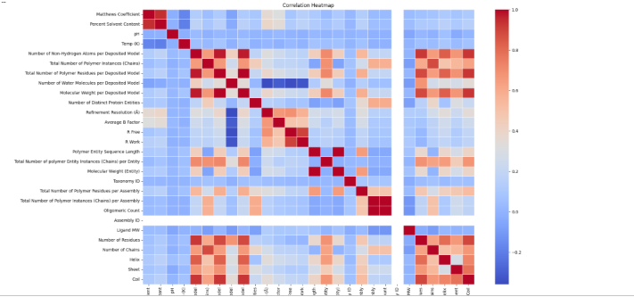
Interpretation
It shows the relationships between numerical variables in the dataset. Strong positive correlations can be seen between many features of protein that are related to size such as molecular weight, number of residues, and sequence length. Most variables show weak to moderate correlations with the Average B Factor, and that shows that predicting the target variable needs combining multiple features rather than relying only on a single predictor.

Figure 2: Molecular Weight Boxplot
The boxplot shows the distribution of molecular weight values and highlights potential outliers.

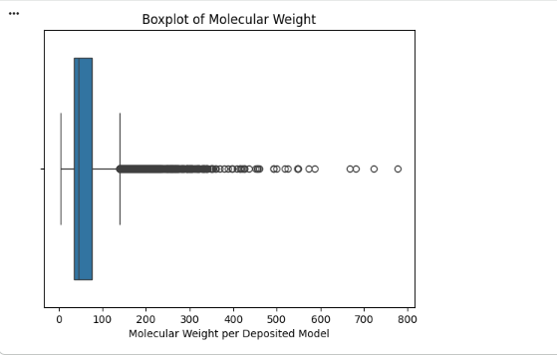
Interpretation:
It shows that most protein structures have molecular weights concentrated within a somewhat small range. However, a large count of outliers are present on the upper side of the distribution, and that indicates that some proteins are significantly larger than the most of structures in the dataset. These outliers were retained because they may represent biologically meaningful observations.

Figure 3: Average B Factor Distribution
The histogram shows the distribution pattern of the chosen target variable.

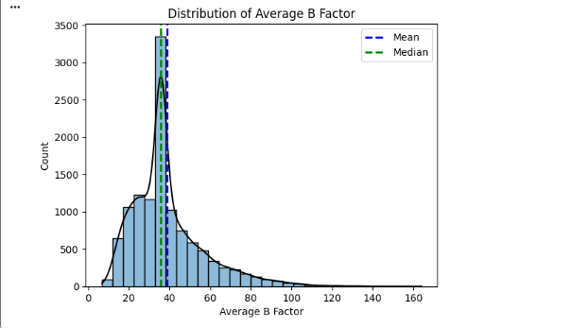
Interpretation:
It shows that the Average B Factor follows a positively skewed distribution. Mostly the protein structures have Average B Factor values between 20 and 50, while a smaller number extend toward bigger values. The close proximity of the mean and median shows a reasonably consistent distribution despite the presence of the long right tail.

Figure 4: Molecular Weight vs Average B Factor
The scatter plot shows the relationship between molecular weight and Average B Factor.

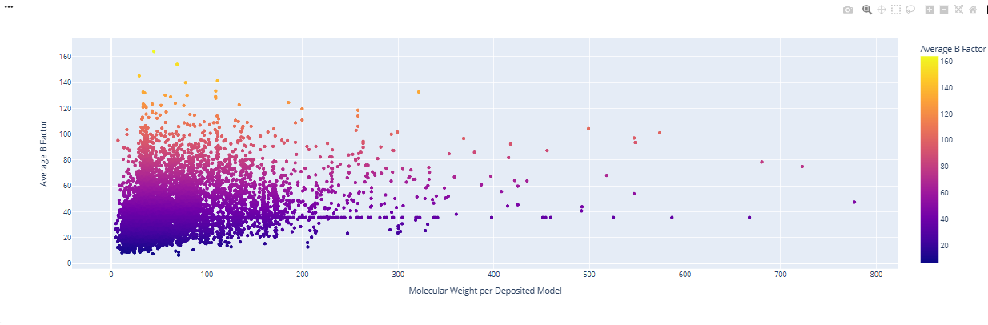
Interpretation:

It shows the relationship between molecular weight and the Average B Factor. The points are really scattered, and that indicates that molecular weight alone is not enough to accurately predict the target variable. Even though the larger proteins show a wider range of Average B Factor values, there are still no strong linear relationship observed.

Figure 5: Entity Polymer Type Distribution
This figure presents the distribution of polymer types in the dataset.
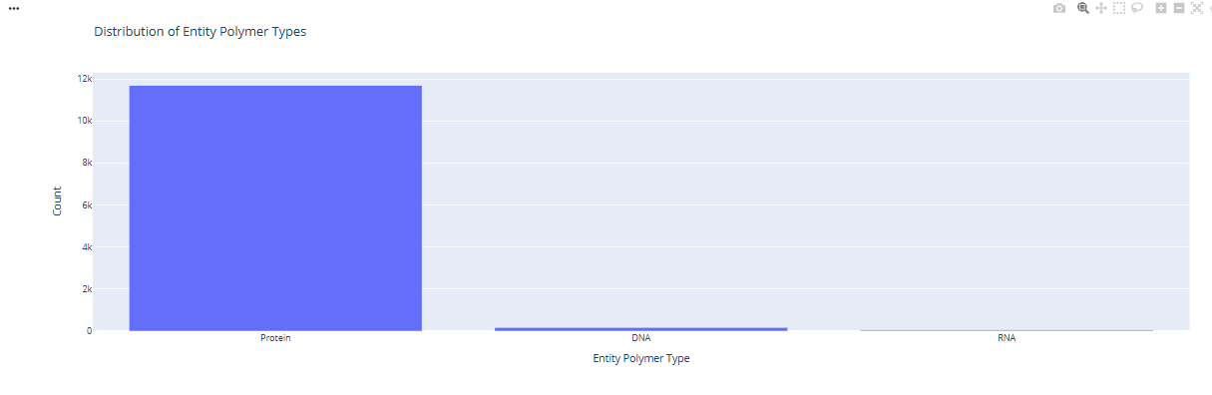
Interpretation:
The distribution of entity polymer types indicates that proteins form the bigger majority of observations in the dataset, while DNA and RNA structures are only a small fraction. This shows that the dataset is highly dominant in protein, which is expected given the focus of the study is on protein structural properties.

5. Model Development and Evaluation
Three machine learning models were used and then compared.

5.1 Linear Regression
Linear Regression was used as a baseline model to set up a reference performance level.

5.2 Decision Tree Regressor
Decision Tree Regressor was executed to collect the nonlinear relationships among variables.

5.3 Random Forest Regressor
Random Forest Regressor was chosen as a group learning algorithm since it combines multiple decision trees to improve the prediction accuracy and to reduce overfitting.
5.4 Comparesion
Model | R^2 score
Linear Regression | 0.388
Decision Tree | 0.213
Random Forest | 0.584
The results show that Random Forest got the highest predictive performance between the three models.

5.5 Hyperparameter Tuning
Then GridSearchCV was done to optimize the Random Forest model.
Best Parameters were:
- max_depth = 10
- n_estimators = 50
The optimized Random Forest model achieved the best performance overall and was chosen as the final model.

6. Deployment
The final trained Random Forest model was then deployed using Streamlit to make an interactive prediction interface as a web page.
Simply, the users can enter a protein structural features and they’ll receive a real time predictions for the Average B Factor.

Figure 6: Streamlit Application Interface
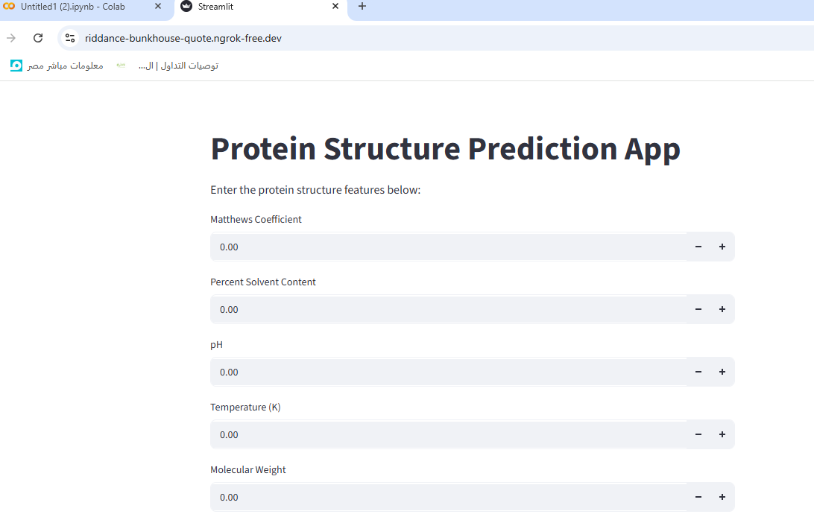

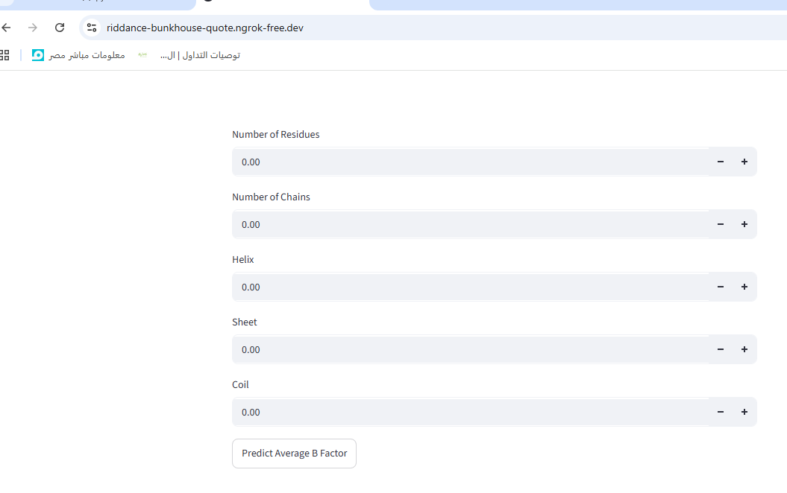
The deployment phase shows how machine learning models can actually be transformed into real practical applications.

7. Conclusion
To sum up. this project was made to apply machine learning techniques to predict the Average B Factor of protein structures. It included data preprocessing, exploratory data analysis, feature engineering, model training, evaluation, hyperparameter tuning, and deployment. And between all models that were used in this project, Random Forest achieved the highest predictive performance with an R² score of 0.584 and was selected as the final deployed model. Finally, the Streamlit application showed an interactive interface for real time prediction and shows the practical application of machine learning in bioinformatics.

